Reproducible data analysis: thesis data analysis and visualization

Pacific Maritime forWater Masters Project (NSERC forWater)

Hannah J McSorley

2020-01-31

# Data Visualization & Summary

plots.

## DOC concentrations

Figure 1 shows DOC concentrations were highest at Weeks Creek, the headwaters monitoring point for a sub-basin which included Weeks Lake and surrounding wetlands. On average, Chris Creek DOC concentration was 51% lower than Weeks creek. Below the confluence of Weeks and Chris Creek, the head of Leech River had a mean DOC concentration slightly less than the average of the two headwater tributatires. West Leech River had higher DOC than Cragg Creek by about 20%. Below the confluences of West Leech and Cragg Creek, the Leech Tunnel site had DOC concentrations that were 54% lower than the average at the Leech head, and closer to those of Cragg Creek.

summary of DOC concentrations at the six main sites

|  |  |  |  |
| --- | --- | --- | --- |
| site | mean DOC (mg/L) | std.dev. (± mg/L) | RSD (%) |
| Weeks-out | 10.4 | 3.6 | 34.4 |
| Chris-crk | 5.1 | 2.1 | 40.9 |
| Leech-head | 7.3 | 1.6 | 22.1 |
| Cragg-crk | 4.7 | 1.5 | 32.4 |
| West-Leech | 5.9 | 2.3 | 39.2 |
| Tunnel | 4.8 | 1.8 | 37.7 |

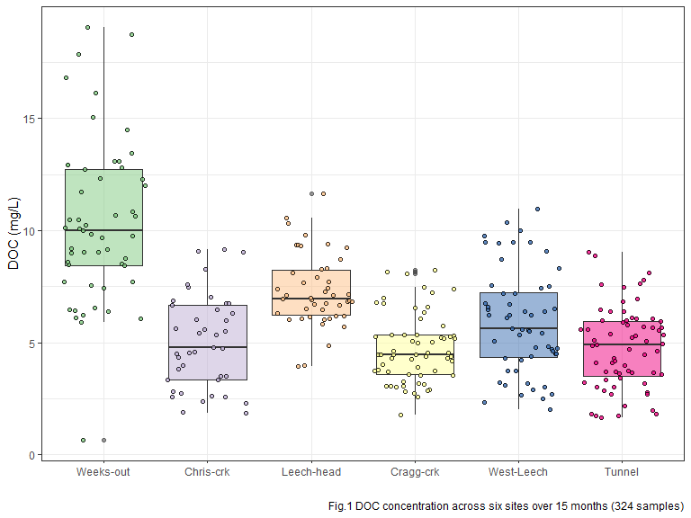

At the six sub-basin monitoring sites, vertical racks were installed to collect samples as the rivers rose in response to precipitation events.

These vertical racks collected samples on the rising hydrograph limb, which has ben shown to have higher DOC concentration that non-storm flow (Yang et al. 2015, @Raymond2016, @Raymond2010). As the vertical racks require a hydrologic response to collect samples, they are only applicable during the wet season. Comparing wet season Grab samples to those collected on Racks confirms that the rack samplers were able to capture more samples, and many during periods with higher DOC concentrations (Fig.2).

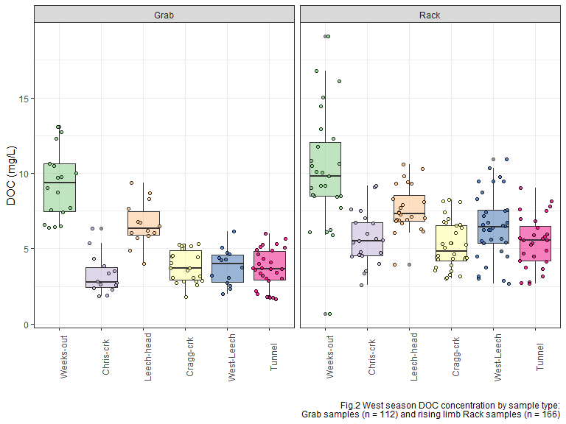

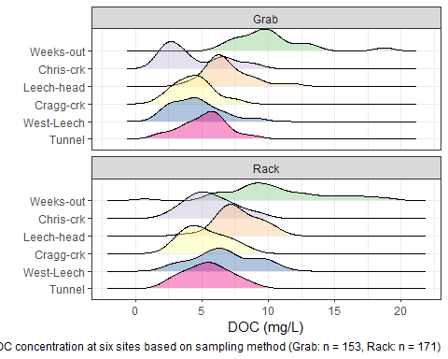

Over the study period, a total of 229 Grab samples were collected. 215 samples were collected from 15 synoptically sampled sites (which included the six installation sites), as well 14 samples collected from one-off opportunistic sample locations around the water supply area. The synoptic sampling program was enhanced by collection of stormflow on the six vertical racks. Over the study period, DOC concentrations decreased throughout the wet season, and increased again during the dry summer months (Fig.3).

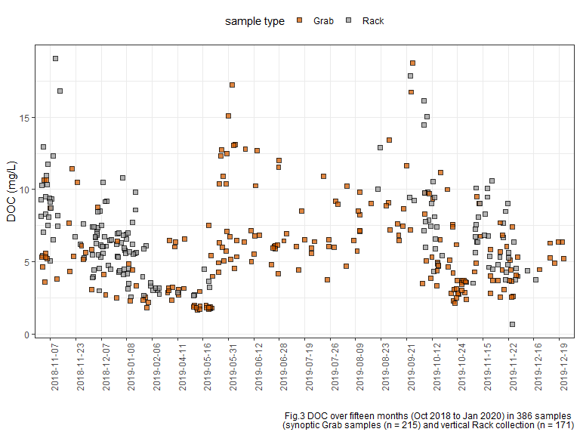

Figure 4 shows DOC concentrations over the study period at each of the six installation locations in the Leech.

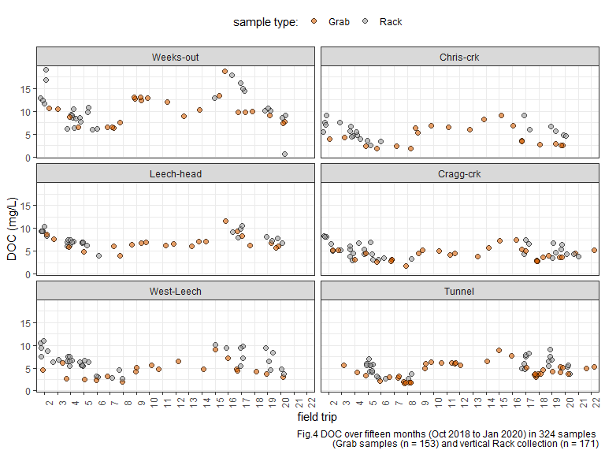

### Seasonal examination of DOC dynamics

Here, a categorical season ID was used to assess temporal variations in DOC. Seasons were separated based on months of the year: the wet season was October through May, and the dry season was June until October.

* Precipitation data will be employed to operationally separate season (data obtained January 31, 2020 from CRD).

These seasonal plots show DOC data from both Rack and Grab samples in order to include the full range of concentrations.

While DOC concentrations generally increased during stormflow (relative to between-storm peaks) in the wet season, the dry season (summer) baseflow conditions showed elevated levels of DOC compared to wet season DOC (Fig.5).

|  |  |  |  |  |
| --- | --- | --- | --- | --- |
| season | site | mean DOC (mg/L) | std.dev. (± mg/L) | RSD (%) |
| Weeks-out | dry | 13.4 | 3.4 | 25.3 |
| Weeks-out | wet | 9.8 | 3.4 | 34.2 |
| Chris-crk | dry | 7.2 | 1.2 | 16.0 |
| Chris-crk | wet | 4.7 | 2.0 | 42.0 |
| Leech-head | dry | 7.6 | 1.9 | 25.3 |
| Leech-head | wet | 7.3 | 1.6 | 21.6 |
| Cragg-crk | dry | 5.4 | 1.5 | 27.2 |
| Cragg-crk | wet | 4.7 | 1.5 | 33.0 |
| West-Leech | dry | 7.1 | 2.1 | 29.9 |
| West-Leech | wet | 5.7 | 2.3 | 40.4 |
| Tunnel | dry | 6.6 | 1.0 | 15.6 |
| Tunnel | wet | 4.5 | 1.7 | 38.7 |

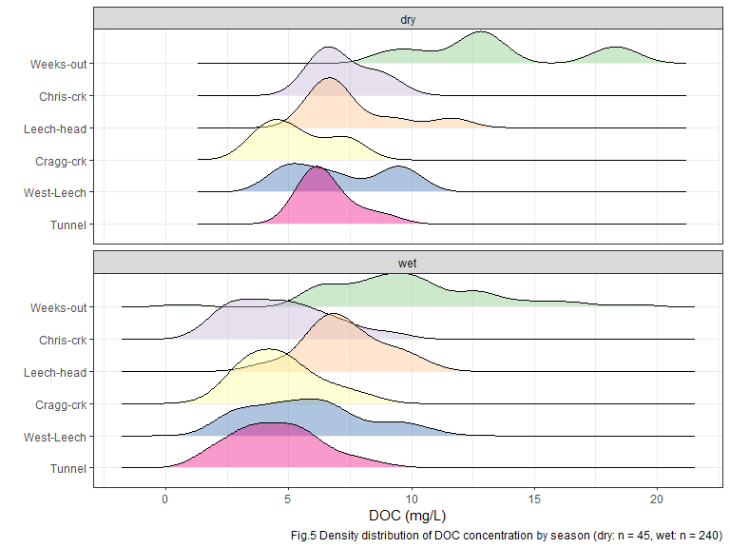

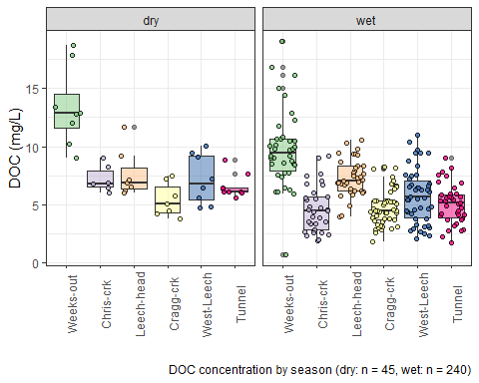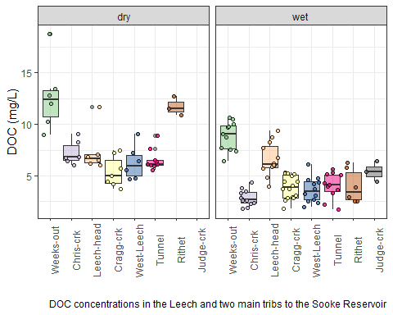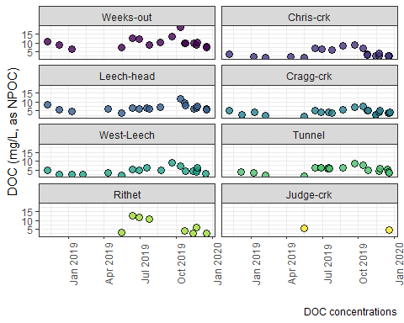

### Plots of DOC & proxy

DOC was quantified as non-purgeable organic carbon (NPOC) on the Shimadzu TOC autoanalyzer, and samples were also measured on a Spectrolyser spectrophotometer. A spectrophotometer can only measure the fraction of organic matter that is able to absorb UV or Visible light, and therefore DOC measured on the Spectrolyser was a measure of CDOM and an indicator of aromaticity (molecular character).

Figure 6 shows results from all samples comparing DOC concentrations (as NPOC, direct measure) to CDOM concentrations (UV-Vis, proxy measure of DOC). There was a strong seasonal separation of the relationship between these two measurements. These results indicate a seasonally-driven physiochemical difference in the aquatic NOM in this drinking water supply area.

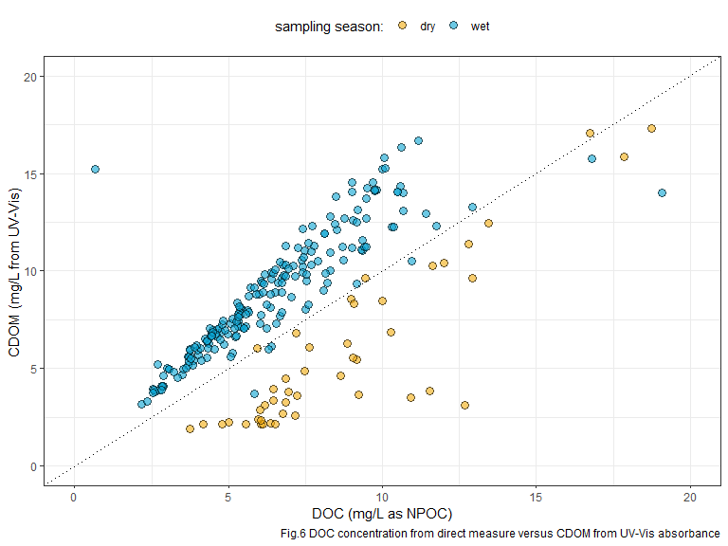

Figure 7 shows the same DOC-CDOM comparison from Figure 6, isolated to the six sub-basin monitoring sites. The seasonal relationship appears similar for the six sites.

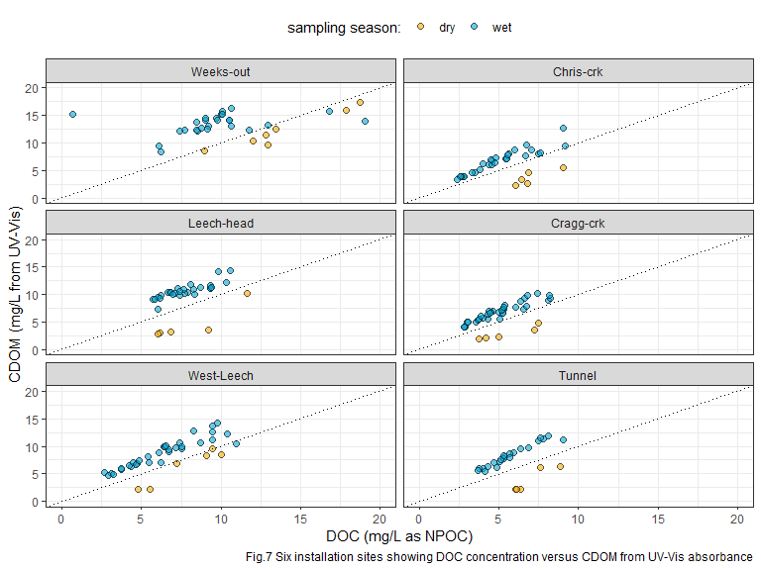

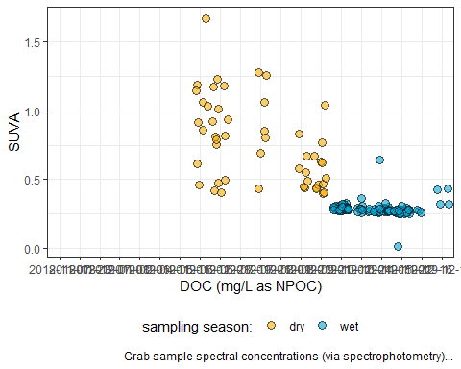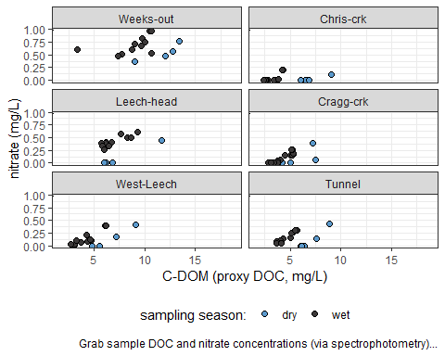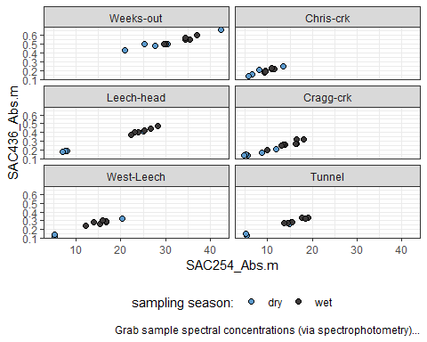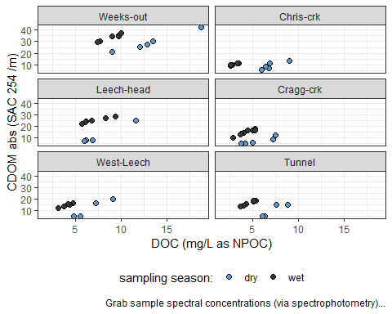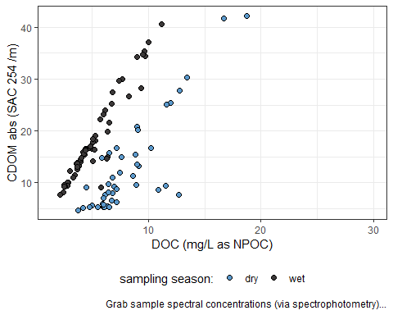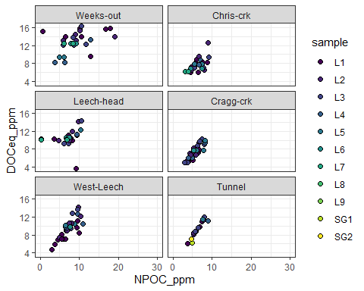

## $x  
## [1] "DOC (mg/L as NPOC)"  
##   
## $y  
## [1] "CDOM (mg/L)"  
##   
## $fill  
## [1] "Rack Position:"  
##   
## $caption  
## [1] "Rack sample DOC concentration based on direct (combustion measuring all non-purgeable organic carbon) and proxy (spectrophotometry measuring chromophoric fraction) methods of quantification..."  
##   
## attr(,"class")  
## [1] "labels"

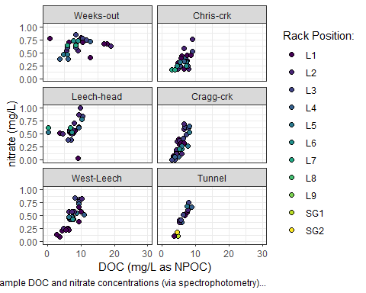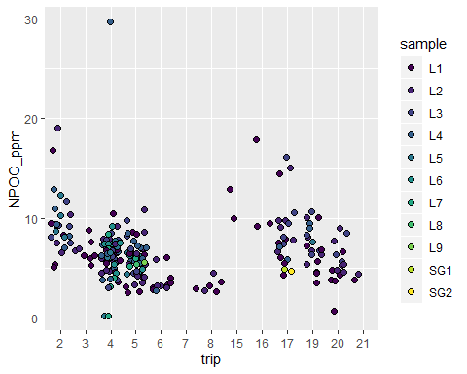

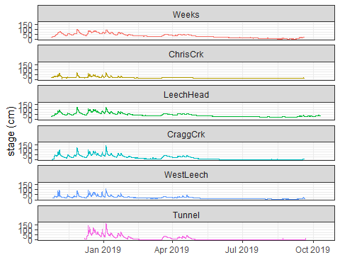

# References

Raymond, Peter A, James E Saiers, Source Biogeochemistry, No September, Peter A Raymond, and James E Saiers. 2010. “Event controlled DOC export from forested watersheds.” *Biogeochemistry* 100 (1): 197–209. <https://doi.org/10.1007/sl0533-010-9416-7>.

Raymond, Peter A, James E Saiers, William V Sobczak, and E James. 2016. “Hydrological and biogeochemical controls on watershed dissolved organic matter transport: pulse-shunt concept.” *Ecology* 97 (1): 5–16. <https://www.jstor.org/stable/24702986>.

Yang, Liyang, Jin Hur, Sonmin Lee, Soon Woong Chang, and Hyun Sang Shin. 2015. “Dynamics of dissolved organic matter during four storm events in two forest streams: source, export, and implications for harmful disinfection byproduct formation.” *Environmental Science and Pollution Research* 22 (12): 9173–83. <https://doi.org/10.1007/s11356-015-4078-6>.